Chapter 3

Ingesting Data Using Azure Data Factory

Introduction

Azure Data Factory (ADF) stands at the forefront of Microsoft’s cloud-based data integration services, empowering organizations to orchestrate, automate, and manage data movement and transformation. As the demand for modern analytics solutions escalates, ADF provides a scalable and cost-effective platform to ingest, prepare, and transform data across disparate sources—whether on-premises, in the cloud, or hybrid environments.

Azure Data Factory (ADF) is Microsoft’s cloud-based data integration service that allows organizations to orchestrate and automate data movement and transformation across a wide range of data sources. Designed to address the challenges faced by modern enterprises, ADF offers a unified platform for constructing, managing, and monitoring complex data pipelines.

At its core, Azure Data Factory is a serverless, fully managed service designed to simplify complex data integration scenarios. It supports the ingestion, transformation, and loading (ETL/ELT) of data from on-premises sources, cloud-based platforms, and Software-as-a-Service (SaaS) applications. By centralizing data movement and transformation, ADF empowers organizations to make data-driven decisions and foster advanced analytics and machine learning initiatives. It offers visual tools for pipeline creation, data movement, and transformation, alongside robust monitoring and management capabilities. By supporting a range of connectors, ADF ensures seamless integration with relational databases, file systems, SaaS offerings, and big data platforms.

Key components of ADF include:

* **Pipeline**: The core unit of work in ADF. A pipeline is a logical grouping of activities that together perform a task.
* **Activity**: Each step in a pipeline, such as copying data or transforming it with Data Flows or custom code.
* **Datasets**: Represent data structures (like tables, files, or folders) used by activities as inputs or outputs.
* **Linked Services**: Define the connection information for data sources and sinks, such as databases, blob storage, or external services.
* **Triggers**: Initiate pipeline execution based on schedules or events.
* **Integration Runtime**: The compute infrastructure used by ADF to move and transform data. It can be Azure-hosted, Self-hosted, or Azure-SSIS.

Organizations leverage ADF for a variety of scenarios:

* Data migration between on-premises and cloud systems.
* Consolidation of data from multiple sources for analytics.
* Building data lakes and data warehouses.
* Real-time and batch data integration for reporting and machine learning.

**Example**: Integrating Data from SQL Server and Azure Blob Storage

Suppose a retail company wants to combine sales data stored in an on-premises SQL Server with product information in Azure Blob Storage. With ADF, the company can create a pipeline that ingests data from both sources, transforms the data as needed, and loads it into an Azure SQL Data Warehouse for business intelligence reporting.

In this chapter, we will delve into hands-on recipes, showcasing the practical application of these concepts.

# ADF as an Enterprise Integration Platform (iPaaS)

ADF is not just a data movement tool; it’s a robust enterprise integration platform as a service (iPaaS). Here’s why it’s so well-suited for enterprise integration:

* **Unified Orchestration**: ADF orchestrates data, logic, and workflows across cloud and on-premises sources, offering a single pane of glass for managing complex integrations.
* **Hybrid Connectivity**: With self-hosted integration runtimes, ADF bridges the gap between on-premises and cloud, enabling seamless hybrid scenarios that are essential for large enterprises.
* **Broad Connector Library**: Out-of-the-box connectors to hundreds of data sources (databases, file systems, APIs, SaaS apps) mean you can integrate almost anything with minimal custom effort.
* **Scalability and Reliability**: Enterprises can trust ADF’s auto-scaling capabilities, high availability, and robust SLAs, which are critical for mission-critical integration flows.
* **Security and Governance**: Native integration with Azure Active Directory, Key Vault, and compliance certifications means sensitive data stays protected, which is vital for regulated industries.

Creating Pipelines

Think of ADF as an orchestrator for your data—an intelligent workflow engine that connects a wide array of data sources, both on-premises and in the cloud, allowing you to copy, transform, and load data into your desired destination. The platform is designed for scalability and flexibility, supporting everything from simple data copying tasks to complex ETL (Extract, Transform, Load) pipelines.

Pipelines are the backbone of the Azure Data Factory ecosystem. They encapsulate sequences of activities, orchestrating complex data workflows with clarity and control. Pipelines organize and streamline data movement, transformation, and orchestration. This section details the process of designing and constructing effective pipelines.

**Understanding Pipelines**

A pipeline in ADF comprises a collection of activities that execute in a defined sequence or parallel as required by the data movement and transformation logic. The modular approach of pipelines enhances reusability, maintainability, and scalability.

**Steps to Create a Pipeline**

* Step 1: Define the Objective. Clearly outline the data movement or transformation goals.
* Step 2: Identify Data Sources and Destinations. Determine the source(s) and sink(s) of the data.
* Step 3: Set Up Linked Services. Configure connections to data stores using linked services.
* Step 4: Create Datasets. Define the structure of data to be processed.
* Step 5: Add Activities. Insert and configure activities such as Copy, Data Flow, Lookup, or Web activities.
* Step 6: Configure Execution Logic. Set activity dependencies, conditional flows, and error handling.
* Step 7: Publish and Trigger the Pipeline. Deploy the pipeline and execute it using manual triggers, schedules, or events.

**Example**: A Simple Copy Pipeline

Consider a scenario where a university wants to periodically copy student enrollment data from an on-premises SQL Server to Azure Data Lake Storage for further analysis:

- Create linked services for on-premises SQL Server and Azure Data Lake Storage.

-Define datasets for the source SQL table and the destination Data Lake folder.

-Insert a Copy Data activity in the pipeline, referencing the datasets and linked services.

-Set up a trigger to run the pipeline nightly.

**Best Practices in Pipeline Design**

* Modularize pipelines for different logical tasks (e.g., ingestion, transformation, loading).
* Parameterize pipelines for flexibility and reusability.
* Implement logging and error handling activities.
* Test pipelines with sample data before full-scale deployment.

Step-by-Step Guide: Creating a Data Pipeline

* Step 1: Log in to the Azure Portal and navigate to your Azure Data Factory instance.
* Step 2: Open the Author & Monitor interface by clicking "Author" in the left menu.
* Step 3: Click the + icon next to Pipelines and select "Pipeline".
* Step 4: Name your pipeline (e.g., "IngestCustomerData").
* Step 5: Drag a "Copy Data" activity into the pipeline canvas.
* Step 6: Configure the activity by specifying source and destination datasets (see next section for dataset creation).
* Step 7: Validate the pipeline and click "Debug" to test your configuration.
* Step 8: Once validated, publish the pipeline and run it.

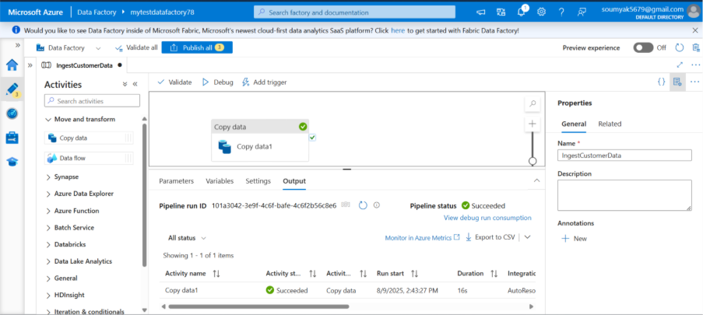

Figure 3.1: Creating a pipeline in ADF

Example Code Snippet – ARM Template for Pipeline

*{*

*"name": "IngestCustomerData",*

*"properties": {*

*"activities": [*

*{*

*"name": "CopyCustomerData",*

*"type": "Copy",*

*"inputs": [ { "referenceName": "CustomerSource", "type": "DatasetReference" } ],*

*"outputs": [ { "referenceName": "CustomerSink", "type": "DatasetReference" } ]*

*}*

*]*

*}*

*}*

## Recipe - Creating a Data Pipeline

* Step 1: In Azure Data Factory Studio, click "New Pipeline."
* Step 2: Add a "Copy Data" activity and configure its source/destination datasets.
* Step 3: Validate, debug, and publish the pipeline.
* Step 4: Trigger a pipeline run manually or via schedule.

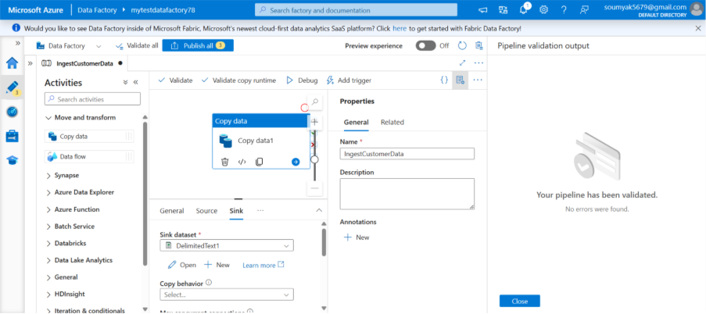

*Figure 3.2: Configuration for Pipeline creation*

Copying Data from On-Premises to Azure

In today’s digital landscape, organizations increasingly rely on cloud platforms for scalable, secure, and efficient data management. Among the various solutions, Azure Data Factory (ADF) stands out as a powerful cloud-based data integration service that makes it remarkably straightforward to orchestrate and automate data movement and transformation. One of the most common use cases for ADF is copying data from on-premises environments to cloud destinations like Azure Blob Storage. This process, while highly effective, involves several components that work in tandem to ensure data is moved securely, reliably, and efficiently. Let's delve into these components—Linked Services, Integration Runtime, and copy data configuration—to get a clear picture of how the whole setup works.

At the heart of any data movement operation in ADF are Linked Services. If you consider a pipeline as a set of instructions telling ADF what to do, then Linked Services are like connection strings, letting ADF know where to fetch data from and where to deliver it.

* **On-Premises Linked Service**: This is typically a connection to a database or file system residing within your organization’s local network—such as SQL Server, Oracle, or even a file share. When you set up a Linked Service for your on-premises source, you define credentials, network paths, and other necessary details ADF needs to establish a secure link.
* **Azure Target Linked Service**: For storing data in the cloud, Azure Blob Storage is a popular target. Here, the Linked Service for Azure Blob requires information like your storage account name, access keys, or managed identities to connect securely to your cloud storage destination.

Setting up Linked Services is mostly a matter of filling out configuration forms in the ADF portal. For on-premises connections, you’ll often need to install and register a data gateway, which acts as a secure conduit between your local network and the Microsoft cloud. Lets explore how to setup pipeline.

* **Pre-requisite**: Install and register the Self-hosted Integration Runtime on your on-premises environment.

*Figure 3.3: Integration Runtime Express setup*

* Step 1: Create Linked Services for your on-premises source and Azure destination (e.g., Azure Blob Storage).
* Step 2: In your pipeline, configure a Copy Data activity referencing these linked services.
* Step 3: Map source and sink schemas as needed.
* Step 4: Validate and run the pipeline.

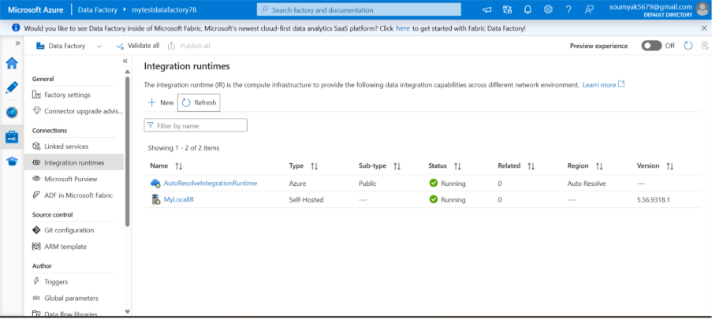

*Figure 3.4: Integration Runtime and Copy Data configuration*

## Practical Example: From SQL Server to Azure Blob Storage

Let’s say your organization wants to move customer order data from a local SQL Server database to Azure Blob Storage for analytics. You’d start by creating two linked services: one pointing to your on-premises SQL Server (with relevant server address, port, and authentication details), and another to your Azure Blob Storage account (with storage credentials).

While Linked Services define the where, the Integration Runtime (IR) answers the how. IR is the compute infrastructure used by Azure Data Factory to provide data integration capabilities across different network environments.

There are three types of Integration Runtime:

* **Azure Integration Runtime**: Handles data movement and transformation in the cloud. Ideal for cloud-to-cloud data transfers.
* **Self-hosted Integration Runtime**: This is crucial for moving data between on-premises sources and the cloud. Installed on a local machine or server, it acts as a gateway, securely moving data from your internal network to Azure and vice versa.
* **Azure-SSIS Integration Runtime**: Used specifically for running SQL Server Integration Services packages within ADF. This is more specialized and often used for organizations with existing SSIS investments.

For our scenario, where data moves from on-premises to Azure, Self-hosted Integration Runtime is the go-to choice. It is installed on a server within your local environment, registered with ADF, and configured to access both your local data sources and the cloud. The self-hosted IR encrypts data during transit and offers robust logging and monitoring features.

## Setting Up Self-hosted Integration Runtime

Setting up the self-hosted IR involves downloading the IR software from the ADF portal, installing it on your chosen on-premises server, and registering it with your Data Factory. The process is guided, user-friendly, and includes steps for configuring proxy settings, managing credentials, and ensuring network connectivity.

## Configuring the Copy Data Pipeline

With Linked Services and Integration Runtime in place, you can now configure your Copy Data activity—the core component of your pipeline responsible for actually moving the data.

* **Source Configuration**: You define what data you want to copy by specifying the source Linked Service. You can select entire tables, write custom queries, or point to specific files or folders. Advanced features like filtering, incremental loading, and schema mapping are available for complex scenarios.
* **Destination Configuration**: Similarly, you tell ADF where to land the data using the target Linked Service—such as a specific container or folder in Azure Blob Storage. You can set file formats (CSV, Parquet, JSON, etc.), naming conventions, and partitioning options to best suit your downstream analytics or storage needs.
* Mapping and Schema Handling: During configuration, you have the chance to map source columns to destination columns, apply transformations, or even perform data type conversions on the fly.

## Pipeline Orchestration and Monitoring

Once your Copy Data activity is configured, you wrap it into an ADF pipeline and define triggers—either run it manually, or schedule it to run at specific intervals. ADF provides a rich monitoring dashboard where you can track the status of your data movement, review performance metrics, and troubleshoot errors with detailed logs.

## Best Practices and Tips

* **Secure Your Data**: Always use encryption (in transit and at rest) and avoid hard-coding sensitive information. Leverage Azure Key Vault for managing secrets and credentials.
* **Monitor and Optimize**: Use the built-in monitoring tools to keep an eye on pipeline performance. Batch large data transfers where possible to maximize throughput and minimize costs.
* **Incremental Loads**: For large or regularly changing datasets, consider implementing incremental loading strategies, moving only new or updated data instead of the full dataset every time.
* **Testing**: Thoroughly test your pipelines with sample data before running them in production. This helps catch schema mismatches or connectivity issues early on.
* **Documentation**: Keep thorough records of your pipeline configurations, Linked Service definitions, and IR setups to facilitate future maintenance or troubleshooting.

Copying data from on-premises sources to Azure using Azure Data Factory may seem complex at first, but once you break it down into linked services (which connect your endpoints), integration runtime (which moves your data), and copy data configuration (which defines what and how data is transferred), the process becomes logical and manageable. With careful planning, secure configuration, and proper monitoring, ADF enables seamless, reliable data migration—unlocking the full potential of cloud analytics and storage for your organization. Whether you're modernizing your data infrastructure or simply backing up legacy systems, mastering these components will help you get the most out of Azure Data Factory’s robust capabilities.

Configuring Data Flows

Data flows enable visually designed, scalable, and reusable data transformation logic. Unlike traditional pipelines, data flows execute on Azure’s managed Spark clusters, supporting rich transformation operations.

Data has truly become the lifeblood of modern organizations, and cloud services like Azure Data Factory (ADF) are at the heart of the movement towards scalable, reliable, and efficient data engineering. Azure Data Factory provides a robust platform for creating, managing, and orchestrating data pipelines—allowing users to move and transform data across diverse sources and sinks. One of the most powerful features within ADF is its concept of Data Flows: these are visually designed, scalable data transformation activities within your data pipelines.

Data Flows in Azure Data Factory allow users to design data transformation logic in a visual and code-free manner. Instead of writing complex scripts, you can use drag-and-drop components to shape, clean, enrich, and aggregate data before loading it into its destination. Data Flows are executed on an Azure-managed Spark cluster, which means they scale automatically to meet your data processing needs.

Azure Data Factory offers two flavors of Data Flows:

* **Mapping Data Flows**: Used for batch data transformation tasks with a rich set of built-in transformations like join, aggregate, filter, and sort.
* **Wrangling Data Flows**: Powered by Power Query, used for data preparation and cleansing with a focus on self-service data wrangling.

Data Flows in Azure Data Factory enable data engineers and architects to design visually rich, scalable data transformation logic without writing code. This section explores the essentials of configuring Data Flows and how they integrate into the pipeline ecosystem.

Data Flows are a visual data transformation feature in ADF, allowing for code-free design of complex ETL logic. Data Flows run on Azure Databricks clusters managed internally by ADF, enabling high-performance, scalable transformations.

## Mapping Data Flows

Mapping Data Flows are the workhorse of data transformation in Azure Data Factory. They provide a rich set of transformations and are best suited for advanced data manipulation, cleansing, and shaping tasks.

Mapping Data Flows are built using a graphical user interface where you assemble transformation activities by connecting various steps like source, filter, join, aggregate, derive, and sink. You can also perform complex logic like conditional splits, lookups, and even implement windowing functions.

## Example: Transforming Customer Data

Let's say you have a customer dataset coming from multiple sources—some records are duplicated, some have missing fields, and values like phone numbers or addresses may need to be standardized.

Using Mapping Data Flows, your transformation could look like this:

* Source: Load customer data from Azure SQL Database and CSV files stored in Azure Blob Storage.
* Union: Combine both sources into a single dataset.
* Aggregate: Group by customer ID and pick the latest record for each customer to remove duplicates.
* Derived Column: Format phone numbers and addresses to a consistent style.
* Filter: Remove records with missing essential information.
* Sink: Save the cleaned data to Azure Data Lake Storage.

All of these actions are performed visually, with data preview available at every step. You can even debug your flows interactively, making it easy to catch errors before running at scale.

## Wrangling Data Flows

Wrangling Data Flows are designed for data preparation and exploration, especially when you need to quickly shape and clean data before deeper transformation or analytics. They're powered by Power Query—the same technology behind Excel and Power BI—which means users familiar with those tools will feel right at home.

Wrangling Data Flows are ideal for scenarios where you want to perform lightweight data preparation and transformation, such as removing columns, filtering rows, and merging datasets. The experience here is highly interactive and geared towards business analysts and data engineers looking for fast prototyping.

## Example: Preparing Sales Data for Reporting

Suppose you receive raw sales data every week, and you need to clean it up before analysis.

In a Wrangling Data Flow, you might:

* Load: Import sales records from a CSV file in Azure Blob Storage.
* Remove Columns: Delete unnecessary columns like internal notes or system-generated timestamps.
* Filter Rows: Exclude canceled or refunded orders.
* Merge: Combine with a product lookup table for enrichment.
* Rename Columns: Standardize column names for consistency.
* Export: Output cleaned data to Azure SQL Database for reporting.

All these steps are performed through a simple drag-and-drop interface, and you can see data previews after each transformation.

To help clarify when to use each type, here's a comparison of their core features:

|  |  |  |
| --- | --- | --- |
| Feature | Mapping Data Flows | Wrangling Data Flows |
| Primary Use Case | Complex, scalable data transformation and ETL | Interactive data preparation, shaping, and exploration |
| Underlying Technology | Azure-managed Spark | Power Query (on Spark) |
| Transformation Scope | Wide range: joins, aggregates, window functions, conditional logic, custom code | Basic: filtering, sorting, removing columns, merging, simple transformations |
| Interface | Visual designer with advanced features | Power Query editor (similar to Excel/Power BI) |
| Debugging & Data Preview | Interactive preview, step-by-step debugging | Real-time data preview at every step |
| Audience | Data engineers, architects | Business analysts, data engineers |
| Custom Expressions | Rich expression language | Power Query M language |
| Integration with Pipelines | Fully integrated with ADF pipelines | Can be used in pipelines; best for prep tasks |
| Performance & Scalability | Optimized for large-scale processing | Best for smaller, interactive workloads |

Both Mapping Data Flows and Wrangling Data Flows are integral to Azure Data Factory's vision for modern data engineering. If you're working on hefty, complex ETL processes with diverse data sources and intricate transformation logic, Mapping Data Flows offer the muscle and flexibility you need. On the other hand, if you want to quickly prepare or explore your data—perhaps as a business analyst or during the early stages of a data pipeline—Wrangling Data Flows provide the familiar, user-friendly Power Query experience.

In a nutshell, the choice boils down to your project requirements and user experience preference. Azure Data Factory caters to a wide spectrum of data professionals, making it a versatile platform for all things data in the cloud.

**Creating a Mapping Data Flow**

* Navigate to the ADF authoring UI and select "Add Data Flow."
* Add source and sink transformations to define data movement.
* Apply transformation activities (e.g., join, filter, derive columns).
* Configure settings such as partitioning, schema mapping, and performance tuning options.
* Integrate the Data Flow into a pipeline via a Data Flow activity.

**Example: Data Transformation for Customer Analytics**

A retail chain aims to merge customer transaction history from multiple regions to create a unified view for analytics. Using Mapping Data Flows, they can join datasets from various sources, filter records based on transaction dates, aggregate sales figures, and then output the cleansed data to Azure Synapse Analytics—all visually and without code.

**Parameterization in Data Flows**

Parameterization enhances flexibility by allowing Data Flows to accept dynamic values at runtime—such as file paths, filter values, or date ranges. This is crucial for building reusable and scalable data processing solutions.

**Optimizing Data Flows**

* Leverage partitioning for parallelism and scalability.
* Monitor data flow execution statistics and tune accordingly.

Minimize data shuffling by careful design of transformations.

Step-by-Step Guide: Creating a Data Flow

* Step 1: In ADF Studio, select the Data Flows option under Author.
* Step 2: Click + Data Flow and choose "Mapping Data Flow".
* Step 3: Add a source transformation, configuring it to read data from your chosen dataset.
* Step 4: Add transformation steps such as Filter, Aggregate, or Conditional Split, as needed.
* Step 5: Specify a sink transformation to write the results to the destination.
* Step 6: Debug the data flow with sample data to verify logic.

Example: Transforming Customer Data

- Add a Derived Column transformation to standardize phone numbers.

- Split data into active and inactive customers using a Conditional Split.

- Aggregate sales data by region.

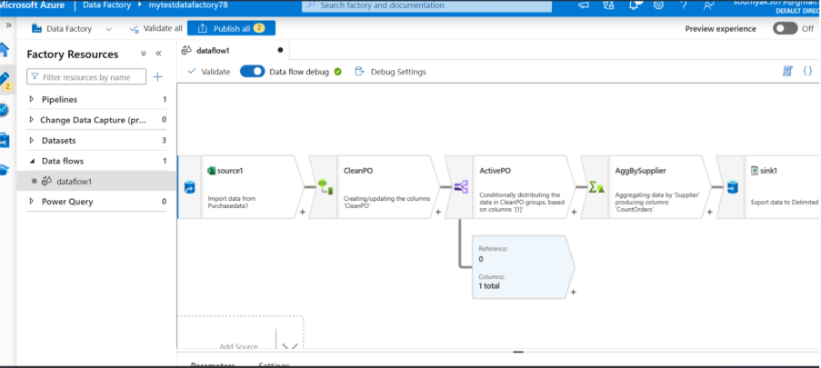

*Figure 3.5: Screenshot of the Mapping Data Flow designer with transformations*

## Transforming Data with Data Flow

Azure Data Factory offers a flexible and scalable way to manage data transformation through its Data Flow feature. With Data Flow, you can visually design your data transformation logic without writing any code. Imagine it as building a pipeline where data passes through a series of steps—filtering, joining, aggregating, and more—until it’s shaped exactly the way you need.

The interface is user-friendly, enabling you to drag and drop various transformation activities and connect them to define the flow of data. Under the hood, Azure Data Factory scales these operations in the cloud, so you don’t have to worry about infrastructure. Whether you need to clean up messy input, combine data from multiple sources, or calculate new columns, Data Flow makes it possible to do all this efficiently and on a large scale. Overall, it simplifies what can often be a complex task, making the transformation process manageable and transparent. Lets see how to create the Data flow in Azure.

* Step 1: Create a new Mapping Data Flow.
* Step 2: Add source and sink transformations.
* Step 3: Insert intermediate transformations: Filter rows, derive columns, join datasets.
* Step 4: Debug and test with sample data.
* Step 5: Publish and execute the data flow.

Sample Data Flow Script:

*source(output(*

*customerId as string,*

*customerName as string,*

*region as string*

*))*

*~> filter(customerId != null)*

*~> derive(standardizedRegion = toUpper(region))*

*~> sink()*

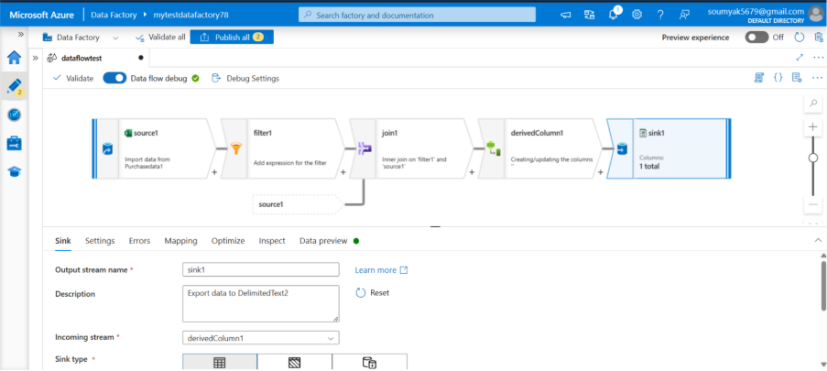

*Figure 3.6: Data Flow designer*

## Incremental Data Loading

Incremental data loading is a smart approach to updating your datasets in Azure Data Factory. Instead of loading an entire dataset each time, you focus only on the new or modified records, which saves time and resources. This is especially valuable when working with large volumes of data that change frequently.

Azure Data Factory supports incremental loading by allowing you to set up your pipelines to check for changes, often by comparing timestamps, row identifiers, or other markers that signal a record has been updated or added. You can configure your pipeline to pick up these changes and process only what’s necessary, ensuring that your target data store stays up-to-date without unnecessary duplication or overhead.

In practice, this means your workflows run more efficiently and your data refreshes are faster, whether you’re moving information into a data warehouse, data lake, or another destination. Incremental loading is a best practice for maintaining reliable and scalable data movement, and Azure Data Factory makes setting it up straightforward.

Here are the steps for Incremental Data loading with Azure Data Factory.

* Step 1: Define a watermark column, such as "LastModifiedDate".
* Step 2: Store the latest loaded value in Azure Table Storage or SQL Database.
* Step 3: In your Source dataset, parameterize the filter to select records where LastModifiedDate > last loaded value.
* Step 4: Update the watermark after each load.

Example Source Query:

*SELECT * FROM Sales WHERE LastModifiedDate > @{pipeline().parameters.lastWatermark}*

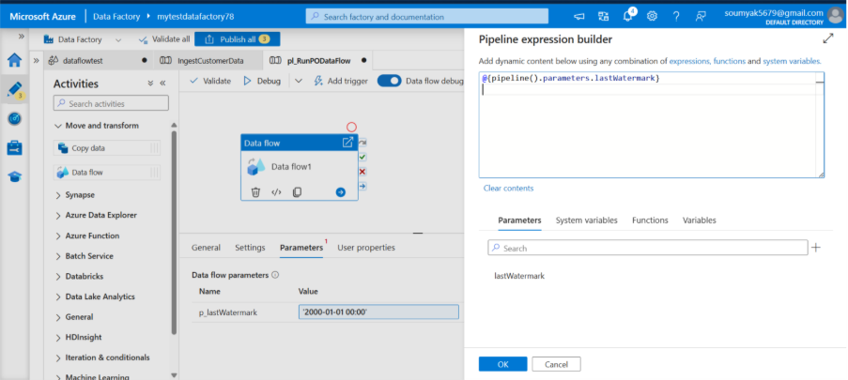

*Figure 3.6: Incremental load parameters and pipeline*

## Scheduling Data Movement

Reliable, timely data movement is crucial for analytics workflows. Azure Data Factory supports event-based, scheduled, and tumbling window triggers for pipeline execution. Orchestrating when and how data pipelines execute is critical for ensuring timely and reliable data delivery. Azure Data Factory offers robust scheduling and triggering capabilities to support both batch and near real-time data integration needs.

**Types of Triggers in ADF**

* Schedule Trigger: Executes pipelines on a specified time-based schedule (e.g., hourly, daily, weekly).
* Tumbling Window Trigger: Initiates pipelines at regular intervals, enabling processing of data in discrete, contiguous windows.
* Event-Based Trigger: Fires pipelines in response to external events, such as the arrival of a file in Azure Blob Storage.

**Configuring a Schedule Trigger**

Suppose a financial analytics team needs to update dashboards each morning with the previous day's data. They can:

* Create a schedule trigger in ADF for 2:00 AM daily.
* Attach the trigger to the primary data ingestion pipeline.
* Enable notifications for success or failure outcomes.

**Tumbling Window Triggers: Use Case Example**

A streaming data pipeline processes IoT sensor data every 15 minutes. Using tumbling window triggers, the pipeline ingests and processes sensor readings in consistently sized, non-overlapping intervals, ensuring all data is captured and processed without gaps or overlaps.

**Event-Based Triggers: Use Case Example**

A logistics company receives shipment manifests as CSV files uploaded to Azure Blob Storage. An event-based trigger monitors the storage container and automatically starts the ingestion pipeline whenever a new file arrives.

**Scheduling with Triggers: Practical Recipe**

* Step 1: After publishing your pipeline, navigate to the "Triggers" tab.
* Step 2: Select New/Edit and choose "Schedule" trigger.
* Step 3: Configure recurrence (e.g., daily at 1:00 AM) and time zone.
* Step 4: Associate the trigger with your pipeline and activate it.

Example Code (JSON):

*{*

*"name": "DailyTrigger",*

*"properties": {*

*"type": "Schedule",*

*"recurrence": {*

*"frequency": "Day",*

*"interval": 1,*

*"startTime": "2024-02-08T01:00:00Z",*

*"timeZone": "UTC"*

*}*

*}*

*}*

Data Transformation Techniques

Data transformation is the process of converting raw data into a format suitable for analysis or operational use. ADF offers a suite of transformation capabilities to clean, standardize, and enrich data as it moves through pipelines. Azure Data Factory (ADF) has grown into a powerhouse for data integration and transformation within the cloud ecosystem. As organizations handle larger volumes of data and seek real-time insights, the range of transformation techniques in ADF becomes crucial. Let’s walk through four prominent data transformation approaches—Data Flow Transformation, Stored Procedure Activity, HDInsight Activity, and Databricks Notebook Activity—highlighting their recent enhancements and their suitability for real-time workloads.

**Core Transformation Activities**

* **Data Flow Transformations**: Join, filter, aggregate, sort, derive columns, and conditional split.
* **Stored Procedure Activity**: Execute stored procedures in databases for advanced, code-based transformations.
* **HDInsight Activity**: Run custom Hadoop, Spark, or Hive jobs for big data transformations.
* **Databricks Notebook Activity**: Integrate custom code written in Python, Scala, or SQL for flexible transformation logic.

**Example: Standardizing Customer Addresses**

Consider a scenario where customer records collected from various sources have inconsistent address formats. Using a Data Flow, ADF can apply string transformations, replace abbreviations, normalize case, and validate postal codes against reference data, resulting in a standardized address dataset.

## Data Flow Transformation

Data Flow in Azure Data Factory is a visually rich, code-free experience for building data transformation logic. You can design transformation pipelines using drag-and-drop features, apply complex logic like aggregations, joins, pivots, and even use expressions to shape data before it lands at its destination.

Recently, ADF has beefed up Data Flows with capabilities such as inline datasets, parameterized source/sink definitions, and improved debugging tools. Enhanced real-time monitoring and scalable execution using Azure’s Spark infrastructure have also been added.

These updates allow businesses to build dynamic pipelines that can adjust to incoming data formats and requirements on the fly—making Data Flow perfect for scenarios where input data can vary and immediate data transformation is needed.

## Stored Procedure Activity

Stored Procedure Activity is a classic yet powerful method, letting you trigger SQL stored procedures directly from your pipeline. This approach is ideal when you want to leverage the processing power of your existing databases for data transformation.

ADF now supports parameterized stored procedure calls, better error handling, and activity chaining, allowing seamless orchestration in complex pipelines.

With improved integration, you can trigger stored procedure activities as soon as new data arrives, enabling low-latency updates and incremental data processing—great for operational reporting and near real-time dashboards.

## HDInsight Activity

HDInsight Activity brings the flexibility of Hadoop, Spark, Hive, and other big data processing engines into your data workflows. You can orchestrate sophisticated batch and streaming jobs, scale them as needed, and handle large data volumes efficiently.

Recent developments include support for managed identities, more granular monitoring, and auto-scaling clusters, which lowers costs and boosts performance for big data jobs.

The enhanced support for Spark Streaming and more streamlined cluster spin-up times allow organizations to process streaming data with less delay, handling real-time analytics and event-driven pipelines with greater efficiency.

## Databricks Notebook Activity

Databricks Notebook Activity in ADF enables integration with Azure Databricks, a collaborative analytics platform based on Apache Spark. This approach is great for advanced analytics, machine learning, or when custom code is necessary.

The integration now supports parameterized notebooks, better version management, and automated job triggers. You can also access improved monitoring and lineage tracking right from ADF.

These improvements make it easier to run dynamic, code-driven transformations as soon as data appears in the system. For example, you could trigger a machine learning model to score incoming records instantly or run complex Python/Scala code on streaming data.

Table 3.1: Key Features of Data Transformation Techniques in ADF

|  |  |  |  |  |  |  |
| --- | --- | --- | --- | --- | --- | --- |
| Technique | Best For | Real-Time Capability | Ease of Use | Scalability | Custom Logic | Recent Features |
| Data Flow Transformation | Visual ETL, dynamic data shaping | High (with debug & triggers) | Very user-friendly | Auto-scaled (Spark) | Moderate (via expressions) | Inline datasets, param sources/sinks, better monitoring |
| Stored Procedure Activity | Database-centric logic | Medium (trigger-driven) | Requires SQL expertise | Depends on DB infra | High (SQL code) | Parameterized calls, robust error handling |
| HDInsight Activity | Massive batch/stream processing | High (esp. with Spark Streaming) | Intermediate, big data skills needed | Highly scalable | Very high (custom scripts) | Managed identities, auto-scaling, better monitoring |
| Databricks Notebook Activity | Advanced analytics/ML | High (event or schedule-based) | User-friendly for coders | Auto-scaled (Databricks) | Very high (Python, Scala, R) | Parameterized notebooks, versioning, lineage tracking |

Each of these techniques comes with its own strengths, and the recent updates make them more versatile and powerful for real-time scenarios. Whether you need a no-code tool, want to leverage existing SQL logic, require the muscle of big data engines, or wish to dive deep into analytics with Databricks, Azure Data Factory provides a toolset to fit almost any data transformation need.

**Advanced Transformation Techniques**

* Pivot and Unpivot: Reshape tabular data as required for analytics or reporting.
* Surrogate Key Generation: Assign unique identifiers for warehouse tables.
* Data Masking: Obscure sensitive information to comply with privacy regulations.

Example: Data Masking for Compliance

A healthcare provider needs to de-identify patient data before sharing with research partners. Within a Data Flow, columns containing sensitive details can be masked or replaced with unique hashes, ensuring regulatory compliance.

Azure Data Factory supports a wide array of data transformation techniques, from basic mapping to advanced data wrangling.

* Mapping Data Flows: Use for visually designing transformations such as joins, filters, aggregations, and lookups.
* Wrangling Data Flows: Ideal for self-service data preparation using Power Query.
* Stored Procedures: Invoke SQL logic as part of your pipeline activities.
* External Activities: Execute Databricks notebooks, HDInsight jobs, or custom code.

Example: Data Cleansing Recipe

- Use a Derived Column transformation to remove whitespace from customer names.

- Filter out records where essential fields are null.

- Standardize date formats using Expression Builder.

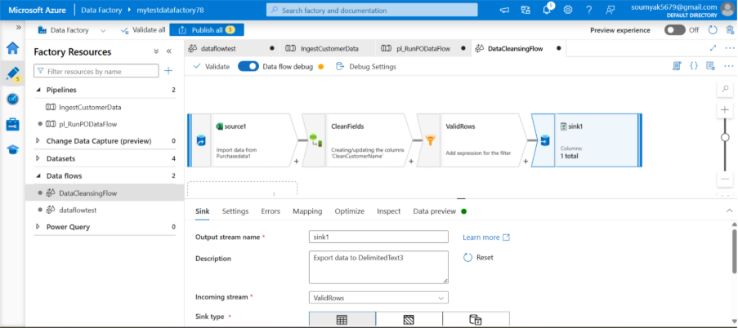

*Figure 3.7: Screenshot of the Derived Column and Filter transformations*

Data Cleansing and Enrichment

When working with data in Azure Data Factory, one of the most important steps is ensuring your data is not only accurate but also meaningful. Data cleansing and enrichment are two key processes that help with this goal. In the ever-evolving world of big data and cloud computing, the quality and reliability of your data can make or break your analytics projects. Before data can yield insights, it must be thoroughly cleaned, enriched, and properly managed. Azure Data Factory (ADF) is a powerful cloud-based data integration service, that not only orchestrates complex data flows but also provides robust tools for data cleansing and enrichment.

## Data Cleansing

Data cleansing is all about cleaning up your data so that it’s reliable and consistent. In Azure Data Factory, you can identify and correct errors, remove duplicate records, fill in missing values, and standardize formats throughout your datasets. For example, if you’re importing customer data from multiple sources, you might encounter issues like inconsistent date formats or misspelled names. Azure Data Factory’s mapping data flows make it simple to set up transformations that fix these problems. This process helps make sure that what you’re working with is high quality and ready for analysis or reporting.

## Data Enrichment

Once your data is clean, the next step is enrichment. Data enrichment takes your existing records and enhances them by adding extra information, often by joining your data with other reference data sources. In Azure Data Factory, enrichment can be performed through various data flow transformations like lookups or joins. For example, you might match customer records with demographic information to gain deeper insights or append additional business data to improve decision-making.

By combining data cleansing and enrichment in Azure Data Factory, you create a workflow where your data becomes not just usable, but genuinely valuable. Clean data means fewer errors down the line, while enrichment ensures your datasets are as informative as possible. Azure Data Factory provides intuitive, scalable tools to automate these tasks, letting you focus more on extracting insights and less on manual data wrangling.

## Understanding Data Cleansing and Enrichment

Data cleansing is the essential process of identifying and rectifying errors, inconsistencies, and inaccuracies in datasets. Think of it as sifting through a pile of pebbles to pick out only the shiniest gems. Data enrichment, on the other hand, involves enhancing raw data with additional information, context, or features—much like adding polish to those gems to make them sparkle even brighter.

While cleansing ensures your data is trustworthy, enrichment boosts its usefulness, enabling richer analytics and smarter decision-making. In big data environments, where information comes from diverse sources and in massive volumes, these steps are absolutely vital.

## Data Cleansing in Azure Data Factory

Azure Data Factory provides several tools and features to facilitate effective data cleansing:

* **Data Flows**: ADF’s Data Flows allow you to design visually rich data transformation pipelines. You can define rules to detect and correct errors, remove duplicates, standardize data formats, and handle missing values—all without writing a single line of code.
* **Mapping Data Flows**: These are especially handy for applying pattern-based transformations. For example, you might use a Mapping Data Flow to trim unwanted whitespace, convert date formats, or delete records with invalid entries.
* **Integration with Azure Functions**: For custom cleansing logic, Azure Data Factory can connect with Azure Functions—letting you embed bespoke scripts or business rules into your data pipelines.

## Common Data Cleansing Scenarios

Within big data projects, data cleansing can cover numerous scenarios:

* **Removing Duplicates**: It’s common for data from multiple sources to contain duplicate records. ADF’s Data Flows can easily identify and eliminate these, reducing noise and storage costs.
* **Handling Missing Data**: Missing values can derail analyses. In ADF, you can replace nulls with default values, estimates, or even interpolate based on existing trends.
* **Correcting Inaccuracies**: Sometimes, data contains typographical errors or inconsistent units (like “kg” vs. “kilogram”). You can use Data Flows to apply transformation rules that standardize these entries.
* **Validating Formats**: Ensuring data follows correct formats (for emails, phone numbers, dates, etc.) avoids downstream errors. Data Flows offer pattern-matching functions for this purpose.

## Data Enrichment in Azure Data Factory

After your data has been scrubbed and polished, it’s time to enrich it. Data enrichment is all about adding context or extra information that makes your data more useful and actionable. Azure Data Factory provides several techniques for enrichment:

* **Data Lookup Transformations**: You can use lookup transformations in Data Flows to enhance your primary dataset with information from reference tables or external sources. For example, enriching transaction data with customer demographic details.
* **Derived Columns**: Create new columns based on existing data, such as calculating age from a date of birth or generating a customer segment tag based on purchase history.
* **Integration with Cognitive Services**: Enrich your data with AI-powered features. For instance, analyze customer feedback with sentiment analysis APIs or extract key phrases using Azure Cognitive Services and feed the results back into your data pipelines.
* **Geocoding and Data Linking**: Enrich addresses by linking them to geographical coordinates or mapping relationships between different datasets for holistic insights.

## Scenarios in Big Data Enrichment

In big data landscapes, enrichment can take many forms:

* **Joining External Data Sets**: Combine internal sales data with open government statistics or market trends to get a broader view of your business environment.
* **Real-time Data Augmentation**: Use streaming data sources and enrich incoming data with real-time attributes—like appending weather conditions to IoT sensor readings.
* **Feature Engineering for Machine Learning**: Prepare enriched features from raw data to improve the predictive power of your machine learning models.

## Data Qualification and Management with ADF

Ensuring high data quality is not just about cleaning and enriching—it also requires ongoing qualification and management. In Azure Data Factory, data qualification refers to the processes that validate, score, and certify the fitness of your data for specific business purposes.

* **Data Validation Activities**: You can add validation steps in your pipelines to check for completeness, consistency, and accuracy before data moves downstream.
* **Automated Testing and Monitoring**: Set up monitoring and alerts to catch data quality issues early. ADF integrates with Azure Monitor and Azure Data Catalog for comprehensive oversight.
* **Metadata Management**: Track the lineage, source, and transformations applied to your datasets, making it easier to audit and manage data assets over time.
* **Version Control and Governance**: Azure Data Factory works hand-in-hand with Azure Purview and Data Catalog to help organizations manage data governance, access control, and versioning.

## Best Practices for Data Cleansing and Enrichment in ADF

Building robust data pipelines is as much an art as it is a science. Here are some best practices to guide your data cleansing and enrichment journey in Azure Data Factory:

* **Profile Your Data First**: Before designing any transformations, use data profiling tools to understand the structure, distribution, and quirks of your incoming data. This helps you tailor cleansing and enrichment logic more effectively.
* **Automate Where Possible**: Set up automated cleansing and enrichment steps using Data Flows and pipeline triggers. Automation reduces manual errors and speeds up data delivery.
* **Modularize Your Logic**: Break down your data transformations into reusable, modular components. For example, create separate Data Flows for standardization, deduplication, and enrichment, then chain them together as needed.
* **Monitor and Log Every Step**: Implement comprehensive monitoring and logging so you can quickly spot and resolve data quality issues. Azure Data Factory integrates with Azure Monitor, providing real-time feedback and alerting.
* **Leverage Built-in and Custom Transformations**: Take advantage of ADF’s diverse set of built-in transformations, but don’t hesitate to use Azure Functions or Databricks notebooks for more complex scenarios.
* **Document Your Pipelines**: Maintain clear documentation on each transformation, rule, and enrichment step to make maintenance easier and onboarding smoother for new team members.
* **Practice Good Data Governance**: Tie your cleansing and enrichment processes into broader governance efforts with tools like Azure Purview to ensure data privacy, compliance, and security.

Data cleansing and enrichment are the unsung heroes of successful data projects—quietly transforming raw, unwieldy information into actionable insights for your business. With a versatile platform like Azure Data Factory, organizations can automate, scale, and govern these processes seamlessly, even in the face of enormous and complex big data volumes. By following best practices and leveraging ADF’s rich toolset, you can unlock the true value of your data, paving the way for smarter analytics, confident decision-making, and a data-driven future. Data cleansing and enrichment in Azure Data Factory are essential for building trustworthy, useful data pipelines that support smarter business decisions. Let’s see the steps in Data cleansing transformation in Data flow.

* Step 1: In a Mapping Data Flow, use the Derived Column transformation to fix data quality issues.
* Step 2: Use Lookup and Join transformations to enrich data from reference datasets.
* Step 3: Apply conditional logic to handle missing or malformed values.

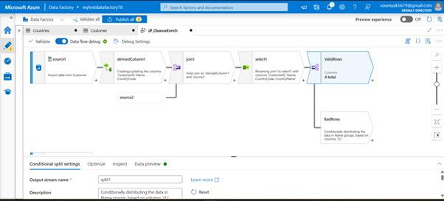

*Figure 3.8: Data cleansing transformations in Data Flow*

## Handling Different Data Formats

* Step 1: Create datasets for each file format: CSV, JSON, Parquet, Avro, etc.
* Step 2: In the Copy Data activity, select format-specific settings (e.g., column delimiter for CSV).
* Step 3: Use schema mapping features to align source and destination schemas.

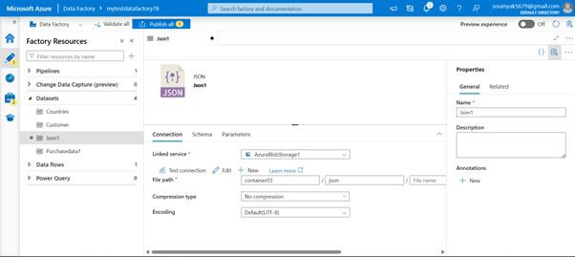

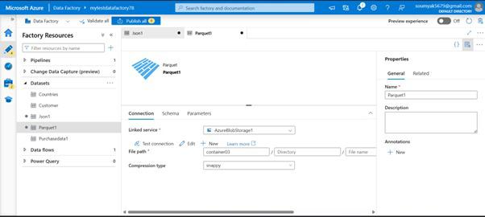

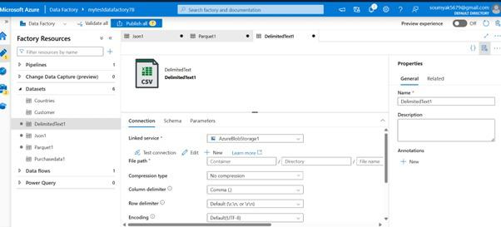

*Figure 3.8: Dataset configuration for multiple formats*

Handling Failures and Retries

No data integration process is immune to occasional failures—be it due to network issues, resource limitations, or unexpected data formats. Architecting robust pipelines that gracefully handle failures and perform retries is crucial for reliability.

In the world of modern data engineering, data integration platforms like ADF have become indispensable. Businesses rely on data pipelines to move, transform, and store information from countless sources, often in real-time. But as with any technology, things don’t always go according to plan. Network hiccups, service interruptions, malformed data—these are just some of the reasons why pipelines can fail. Knowing how to gracefully handle such failures, and when and how to retry, is at the heart of creating reliable, robust data flows.

### Failure Handling and Retries

Let’s face it—no one likes failures, but in the world of data integration, they’re inevitable. APIs might time out, databases could be unavailable, or files could be locked just when you need them most. If these kinds of hiccups aren’t managed adeptly, you risk data loss, pipeline delays, or even system-wide outages.

Here’s why handling failures and retries is so crucial:

* **Data Integrity**: Every failed data movement or transformation step can potentially result in missing or duplicated data. Properly handling failures helps ensure your datasets stay accurate and trustworthy.
* **Operational Resilience**: Automated failure management means fewer manual interventions. Your team can spend less time firefighting and more time building value.
* **Cost Control**: Inefficient retries or unhandled failures can rack up unnecessary compute or storage costs. Smart configuration helps optimize resource usage.
* **User Trust**: Consistent and predictable data pipelines inspire confidence among business users who depend on timely reports and analytics.

To summarize, robust failure and retry strategies are the backbone of a healthy data architecture.

### Understanding Failures in Azure Data Factory

Before diving into solutions, let’s briefly talk about the types of failures you might encounter in ADF:

* **Transient Failures**: These are temporary glitches, such as network interruptions, authentication token expiry, or short-lived service outages. Often, simply retrying resolves the issue.
* **Persistent Failures**: These are repeatable or permanent problems, such as incorrect configuration, missing resources, or invalid credentials. Retrying won’t help until the underlying issue is addressed.
* **Data Quality Failures**: Sometimes, errors arise due to malformed or unexpected data, requiring special handling or notification.

Recognizing the nature of a failure is key—blindly retrying won’t solve persistent or data quality problems and may even make things worse.

### Built-in Failure Handling Features in ADF

Azure Data Factory provides a robust set of features for tackling failures head-on:

## **1. Retry Policies**

Every activity in an ADF pipeline can be configured with a retry policy. This lets you specify how many times to retry a failed activity and how long to wait between attempts. Key properties include:

* **Retry**: The number of times an activity should be retried after a failure. For example, setting this to “3” means the activity gets up to three attempts.
* **Retry Interval**: The time to wait between retries. You might set a few seconds for quick jobs or several minutes for tasks that depend on external systems.

A thoughtful retry policy helps smooth out transient issues without overwhelming your systems or causing unnecessary delays.

## **2. Activity Dependency and Conditional Paths**

ADF pipelines are made up of activities chained together. You can set dependencies so that certain steps only run if the previous step succeeds—or fails. This flexibility means you can define alternate paths, trigger corrective actions, or even send notifications if something goes wrong.

For instance, after a failed copy operation, you might automatically send an alert, log details for investigation, or kick off a cleanup job.

## **3. Error Handling with 'On Failure' Actions**

Activities in ADF can be configured to perform specific actions when they fail. Using the “onFailure” dependency condition, you can trigger alternative flows, alert operators, or perform compensating actions. This is particularly helpful for non-transient errors that require human intervention or logging.

## **4. System Logging and Monitoring**

ADF integrates tightly with Azure Monitor and Log Analytics. These services capture detailed pipeline execution logs, error messages, and metrics. Monitoring tools allow you to track failure rates, analyze trends, and quickly zero in on problematic activities.

Setting up alerts in Azure Monitor means you’ll get notified if a pipeline fails or exhibits unusual error patterns—giving you a heads-up before issues escalate.

## Practical Strategies for Handling Failures and Retries

## **1. Classify Errors Wisely**

Not all errors deserve the same response. Categorize errors in your pipelines as transient, persistent, or data-related. For transient errors, retries make sense. Persistent errors often signal configuration or code issues, and retries may be wasteful or even harmful.

## **2. Tune Retry Logic**

Finding the sweet spot for retry settings is an art. Too few retries, and you might give up on recoverable jobs; too many, and you risk prolonging failures or causing resource contention.

A practical approach is to start with a moderate retry count (e.g., 3) and a sensible interval (e.g., 30 seconds), then adjust based on the reliability of your target systems. For high-latency or batch jobs, consider longer intervals.

## **3. Implement Conditional Flows**

Don’t just stop at retries—leverage conditional paths and “onFailure” actions to handle errors proactively. For example, if a data copy fails after all retries, you could trigger a notification, create an incident ticket, or invoke a remediation script.

## **4. Use Logging and Alerting**

Make sure comprehensive logging is enabled. Use Azure Monitor to track failures, analyze log data, and maintain visibility into your pipelines. Set up automated alerts to catch failures early, so you can respond quickly.

## **5. Document and Review Regularly**

Document your failure handling strategies and periodically review your pipelines. As data sources, destinations, and dependencies evolve, so should your error handling. Continuous improvement helps you adapt to new challenges and stay ahead of issues.

## Tips and Best Practices

* **Don’t Over-Retry**: Avoid high retry counts for activities that fail due to persistent configuration errors—you’ll only delay resolution.
* **Graceful Failure**: Use “onFailure” and conditional branching to fail gracefully, keeping downstream systems and users informed.
* **Idempotency**: Design activities so that retries don’t cause duplicate data or side effects. This is especially important for write operations.
* **Monitor Frequently**: Regularly check logs and metrics to identify patterns in failures. Address recurring issues at their source.
* **Communicate Clearly**: Ensure your team knows what to do when a pipeline fails—clear documentation and notifications are vital.

Building robust data pipelines in Azure Data Factory is about much more than just connecting sources and destinations. It’s about anticipating what might go wrong and having strategies in place to handle it gracefully. By leveraging ADF’s built-in failure handling and retry mechanisms, categorizing errors intelligently, and staying vigilant through monitoring, you can ensure your data workflows are resilient and trustworthy.

Failures are inevitable, but with the right approach, they become manageable bumps in the road—not roadblocks. By investing time in smart failure handling, you’re not just protecting your data—you’re building the foundation for a data-driven organization that can weather any storm.

**Error Handling Strategies**

* **Activity Retry Policies**: Configure activities to automatically retry on failure, specifying retry count and wait intervals.
* **Failure Paths**: Use conditional logic to execute alternate flows when an activity fails, such as sending alerts or initiating compensating actions.
* **Logging and Diagnostics**: Capture detailed logs for auditing and troubleshooting through Azure Monitor and custom logging activities.

Example: Handling Copy Failures

Suppose a pipeline copying data from an external FTP server occasionally fails due to connectivity issues. You can:

-Set retry policies with up to three attempts and increasing wait times between retries.

-Implement an error handling activity that writes failure details to a log file and sends an email notification to the support team.

**Idempotency and Checkpointing**

Design idempotent pipelines that avoid data duplication or loss on re-execution. Use checkpointing to record successfully processed data, ensuring resumed executions pick up where they left off.

Example: Idempotent Data Loads

A pipeline loads daily transaction data into a data warehouse. By marking successfully loaded batches and skipping already processed records, the pipeline stays resilient against re-runs caused by transient failures.

Robust data pipelines anticipate failures and incorporate retry logic, notifications, and error handling.

**Failure and Retry Configuration Guide**

* Step 1: In each activity’s settings, define the Retry policy (e.g., 3 retries, 30-second interval).
* Step 2: Use the "On Failure" output of activities to drive compensating or cleanup actions.
* Step 3: Integrate with Azure Logic Apps or send email notifications for critical failures.
* Step 4: Log error details to Azure Log Analytics for post-mortem analysis.

*Example Configuration (Code):*

*"policy": {*

*"retry": 3,*

*"timeout": "00:20:00",*

*"retryIntervalInSeconds": 30*

*}*

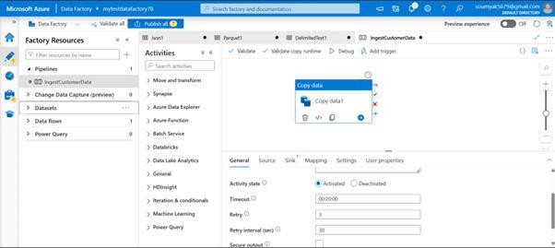

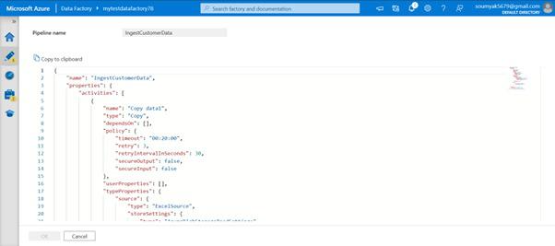

*Figure 3.9: Screenshot of activity error handling settings in ADF*

## Using Parameters for Dynamic Pipelines

In the world of cloud-based data integration, Azure Data Factory (ADF) stands out as a robust platform for orchestrating complex data workflows. One of its most powerful features is the ability to use parameters to create dynamic, flexible pipelines. Let’s explore why parameters matter, when their use is particularly beneficial, and the best practices that can help you make the most of them in your data engineering projects.

Parameters in Azure Data Factory are essentially variables you define at the pipeline level. They allow you to pass in values when a pipeline run is initiated, influencing how that pipeline behaves or what data it processes. Unlike variables, which are mutable only during the pipeline execution, parameters are set at the beginning of the run and remain constant throughout.

For instance, if you have a pipeline that copies data from one location to another, rather than hard-coding specific file paths or database names, you can define these as parameters. This means you can run the same pipeline against different sources or targets simply by passing different values for the parameters, making your workflows much more adaptable.

There are countless situations where using parameters to drive dynamic pipelines in ADF is not just helpful—it’s essential. Here are a few scenarios where this approach proves invaluable:

* **Multi-Source Data Processing**: Imagine you need to ingest data from multiple databases or storage accounts. By parameterizing the source connection details, you can reuse the same pipeline for each source, simply supplying a different parameter value each time.
* **Configurable File-Based Processing**: If your data comes in the form of files—say, daily sales data with filenames that include the date—you can pass the filename or date as a parameter, allowing the pipeline to dynamically pick up the right file.
* **Environment-Specific Deployments**: Moving code from development to test and production environments often means changing connection strings, folder paths, or other details. With parameters, you can maintain a single pipeline definition and vary only the values that are environment-specific.
* **Orchestrating Reusable Workflows**: When you have a sequence of data transformations or loads that are similar but not identical—for example, processing data for different business units—you can use parameters to customize each run, avoiding the need to duplicate your pipeline logic.

Parameters allow you to design pipelines that are generic and reusable, reducing duplication and simplifying maintenance.

## Best Practices for Implementing Parameterized Pipelines

While parameters are powerful, it’s important to follow some best practices to ensure your pipelines remain easy to understand, maintain, and scale. Here are some guidelines to help you get the most from parameterization in Azure Data Factory:

**Define Clear and Purposeful Parameters**

* Only introduce parameters that are genuinely needed for flexibility. Avoid over-parameterizing, which can make pipelines harder to read and maintain. Each parameter should have a clear purpose and be well-documented.

**Use Descriptive Names**

* Naming matters. Choose parameter names that accurately reflect their use, such as SourceFilePath, TargetTable, or LoadDate. This makes it easier for anyone working with your pipeline to understand what each value controls.

**Set Default Values Wisely**

* Providing sensible default values for parameters can be a lifesaver, especially when testing or debugging. Defaults help ensure the pipeline will run even if a particular parameter isn’t specified, but be careful—make sure defaults make sense and won’t cause accidental data issues.

**Validate Parameter Inputs**

* Wherever possible, include checks or validation logic for your parameters. For example, if a parameter should be a date, make sure it’s in the correct format. This helps catch issues early, before the pipeline gets too far into execution.

**Document Parameter Usage**

* Leave comments or documentation describing what each parameter does, what values are expected, and any important constraints. Clear documentation is invaluable, especially as pipelines evolve or are handed off to new team members.

**Leverage Parameterization Across Linked Services and Datasets**

* Parameters are not limited to pipelines alone. You can also parameterize linked services and datasets, making your entire data integration layer more modular. For example, you might define a parameterized connection string and use it in different datasets or activities.

**Test Parameter Combinations**

* Make sure to test your pipelines using a variety of parameter values and combinations. This helps ensure that dynamic logic works as expected and reduces the risk of runtime errors in production.

**Minimize Hardcoding**

* The whole point of parameterization is to avoid hardcoding details that might change. Always prefer passing values via parameters rather than embedding them directly in your pipeline logic.

**Monitor and Log Parameter Values**

* It’s a good idea to log which parameter values were used for each pipeline run, especially for auditing and troubleshooting. This can be done using ADF’s built-in logging or by writing parameter values to a custom log table or file.

Using parameters for dynamic pipelines in Azure Data Factory is a best practice that pays dividends in flexibility, maintainability, and scalability. Whether you’re orchestrating complex data movements across multiple environments, handling files that change daily, or simply aiming to reduce pipeline duplication, parameterization is your friend.

The key is to approach parameterization thoughtfully: only use it where it adds real value, name and document your parameters carefully, validate inputs, and always keep maintainability in mind. When you get it right, you’ll find your data integration solutions are more robust, adaptable, and ready to tackle whatever new requirements come along.

By weaving parameters into your pipeline designs, you empower your team to build data solutions that are not just functional but also elegant, scalable, and future-proof—a hallmark of mature data engineering practice. Following steps explains how to achieve this parameters for dynamic pipeline.

* Step 1: Define pipeline parameters (e.g., file path, table name).
* Step 2: Reference parameters in activity settings and datasets using @pipeline().parameters notation.
* Step 3: Pass parameter values at runtime or via triggers for dynamic execution.

Example:

*"parameters": {*

*"BlobFilePath": {*

*"type": "String"*

*}*

*}*

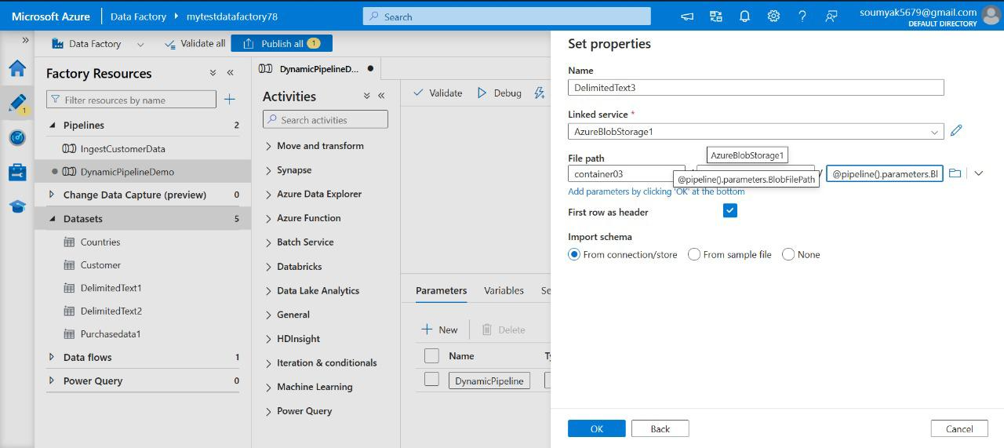

*Figure 3.10: Parameterization in pipeline editor*

Monitoring Data Pipeline Performance

Ensuring the health and efficiency of data pipelines is a continuous process. Azure Data Factory provides comprehensive monitoring and troubleshooting tools to help architects and engineers optimize pipeline performance.

**Monitoring Features in ADF**

* **Monitoring Dashboard**: Visualize pipeline runs, activity status, and trigger executions in real-time.
* **Alerting and Notifications**: Set up automated alerts on pipeline failures, performance thresholds, or custom metrics.
* **Integration with Azure Monitor and Log Analytics**: Export logs and metrics to centralized monitoring solutions for advanced analysis and correlation.

Example: Setting Up Failure Alerts

An engineering team wants to be notified if any data pipeline fails. In ADF, they create alert rules that trigger SMS or email notifications when a pipeline run ends in failure, enabling rapid response and minimizing downtime.

**Performance Tuning Best Practices**

* Optimize data partitioning in Data Flows for parallelism.
* Monitor activity duration and data throughput; identify bottlenecks.
* Scale integration runtimes to match workload demands.
* Review logs for failed activities and implement corrective measures.

Example: Improving Copy Activity Throughput

A logistics company observes slow data ingestion from an on-premises Oracle database. By increasing the integration runtime’s compute size and optimizing the source query, they significantly boost data copy throughput.

Ongoing monitoring enables proactive issue resolution and performance tuning.

**Monitoring with Azure Data Factory**

* Access the Monitor tab in the ADF Studio to view pipeline run history and status.
* Set up alerts using Azure Monitor for failed or long-running activities.
* Analyze metrics such as data throughput, activity execution time, and success/failure rates.
* Leverage integration with Azure Log Analytics for advanced querying and visualizations.

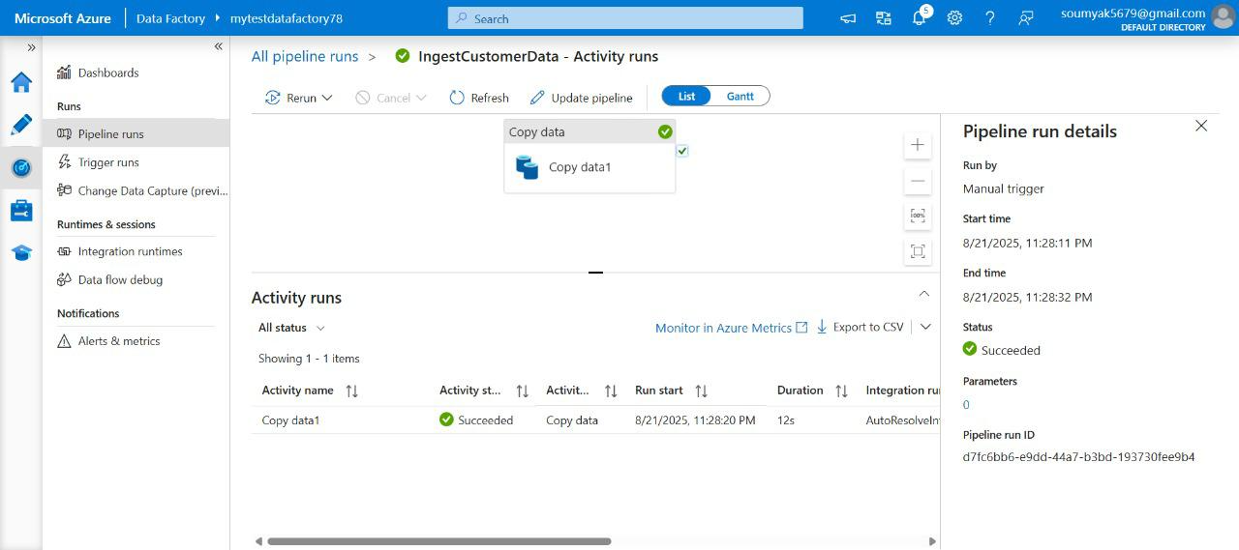

*Figure 3.11: Screenshot of the Monitor dashboard with pipeline run details*

## Monitoring and Troubleshooting Pipelines

ADF is a powerful tool for orchestrating and managing data workflows in the cloud. To ensure your pipelines run efficiently and reliably, it’s crucial to monitor, troubleshoot, and fine-tune them regularly. Whether you’re optimizing performance, right-sizing resources, or debugging issues, a proactive approach makes all the difference. Here’s how you can stay on top of your ADF pipelines, combining best practices with real-world strategies.

## Effective Monitoring of Azure Data Factory Pipelines

The first step in keeping your data pipelines healthy is robust monitoring. Azure Data Factory offers built-in monitoring tools that let you track pipeline runs, activity runs, trigger executions, and system events—all in near real time.

* **Utilize the Monitoring Dashboard**: The ADF portal provides a Monitoring Dashboard where you can view the status of pipeline runs, check for failures, and drill down into specific activity details. Make it a habit to regularly review this dashboard so issues don’t go unnoticed.
* **Set Up Alerts and Notifications**: Leverage Azure Monitor to create custom alerts based on pipeline metrics, such as run failures, long durations, or data anomalies. Email or webhook notifications can keep your team in the loop whenever something goes wrong.
* **Log Everything**: Enable diagnostic logging and send logs to Log Analytics or a storage account. Detailed logs are invaluable when you need to troubleshoot or audit pipeline activity.

## Troubleshooting and Debugging Pipelines

When something isn’t working as expected, ADF provides a variety of tools to help you identify and resolve issues.

* **Understand Error Messages**: Start by reviewing error messages and activity outputs in the monitoring view. These often point directly to configuration mistakes or data format issues.
* **Use Debug Mode**: Take advantage of the Debug mode in the pipeline designer. This allows you to run pipelines with sample data or parameters, helping you pinpoint where things break without affecting production data.
* **Check Data Movement and Transformation Steps**: Review input and output data at each stage. If you notice unexpected results, trace the data lineage to see where transformations may be going wrong.
* **Inspect Linked Services and Datasets**: Misconfigured connections or incorrect dataset formats are common culprits for pipeline failures. Double-check credentials, paths, and schema definitions.
* **Monitor Resource Utilization**: Sometimes, failures stem from insufficient resources or throttling. Use integration runtime monitoring to check CPU, memory, and network usage.

## Performance Tuning and Right-Sizing Resources

Optimizing your pipelines isn’t just about fixing errors—it’s about making your data flows as efficient as possible.

* **Choose the Right Integration Runtime**: Select between Azure, Self-hosted, or Azure SSIS integration runtimes depending on your workload. Each has different capabilities and cost profiles.
* **Scale Out Where Needed**: For high-volume or parallel processing, configure scaling options in your integration runtime to handle more jobs concurrently.
* **Reduce Data Movement**: Minimize unnecessary data transfers between regions or services. Try to process data as close to the source as possible to save time and costs.
* **Tune Activities and Partitions**: For data flows and copy activities, experiment with partitioning, batch sizes, and data flow sampling to find the best balance between speed and resource usage.
* **Monitor Pipeline Performance Metrics**: Regularly review activity duration, throughput, and resource consumption. Use this data to identify bottlenecks and adjust pipeline design or resource allocation accordingly.

## Best Practices for Monitoring and Troubleshooting in ADF

* Automate as much as possible—set up alerts, scheduled reports, and automated tests to catch issues early.
* Document your pipeline designs, configurations, and changes. Good documentation speeds up troubleshooting and onboards new team members smoothly.
* Segment pipelines logically, keeping tasks modular and reusable. This makes it easier to isolate and fix problems without disrupting the whole workflow.
* Use version control for pipeline artifacts so that you can roll back changes or compare pipeline versions if things go awry.
* Collaborate with your team—share insights from troubleshooting sessions and update shared documentation with newly discovered solutions.

In summary, keeping your Azure Data Factory pipelines running smoothly is all about being proactive—monitoring diligently, debugging methodically, and tuning for optimal performance. By following these best practices, you’ll minimize downtime, maximize efficiency, and keep your data operations robust and reliable. Lets check the steps to setup Monitoring and troubleshoot ADF as below.

* Step 1: Use the Monitor tab to review activity and pipeline run history.
* Step 2: Set up alerts for failed or long-running runs via Azure Monitor.
* Step 3: Drill down into activity run details to view logs and error messages.
* Step 4: Integrate with Application Insights or Log Analytics for advanced diagnostics.

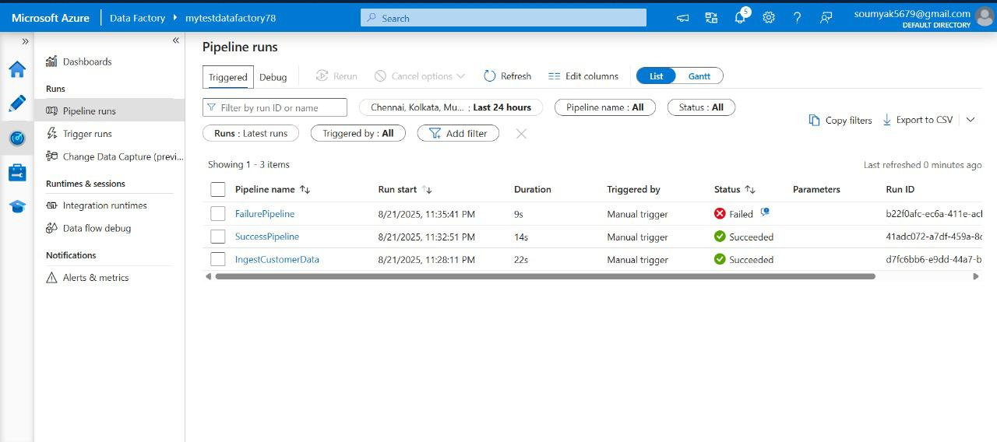

*Figure 3.12: Monitoring dashboards and error logs*

Integrating with Other Azure Services

Azure Data Factory (ADF) is designed to make it easy to bring together data from various sources across the cloud. If you want to connect ADF with other Azure services—like Azure Data Lake, Azure SQL Database, Synapse Analytics, Cosmos DB, or HDInsight—the key feature you'll be working with is called “Linked services.”

A Linked service is essentially a connection string or configuration that tells ADF how to connect to an external resource. Think of it as a bridge between your data pipeline and the service you want to interact with. Setting up a Linked service is usually straightforward: you select the data store type (such as Azure SQL or Data Lake), fill in the authentication details, and specify any other configuration values required.

Say you want to load data from Azure Data Lake into Azure SQL Database. You’d first create a Linked service for your Data Lake storage and another one for the SQL Database. These Linked services are then referenced in your datasets and pipeline activities, letting ADF handle the data movement securely and efficiently.

Integrations aren’t limited to storage or SQL services. If you’re working with analytics, you can connect to Synapse Analytics for large-scale data processing, or plug into Cosmos DB when you need to work with NoSQL data. For big data workloads, Linked services also support HDInsight clusters, enabling ADF to orchestrate jobs on Hadoop or Spark.

The process is largely the same for any supported Azure service: you set up a Linked service, configure credentials, and reference that connection wherever you need it in your data pipelines. This approach streamlines connections and ensures your data movement and transformation processes remain secure and manageable.

Linked services are ADF’s way of enabling smooth, secure integration with all sorts of Azure-native services. By configuring these connections, you unlock powerful, automated workflows that stretch across Azure’s diverse ecosystem, making it simple to blend, transfer, and process data wherever you need. Here are the steps to integrate ADF with other Azure services.

* Step 1: Use Linked Services to connect to Azure Data Lake, Azure SQL, Synapse, Cosmos DB, HDInsight, and more.
* Step 2: Trigger Databricks Notebooks or Azure Machine Learning activities from pipelines.
* Step 3: Move data seamlessly between Azure services within orchestrated workflows.

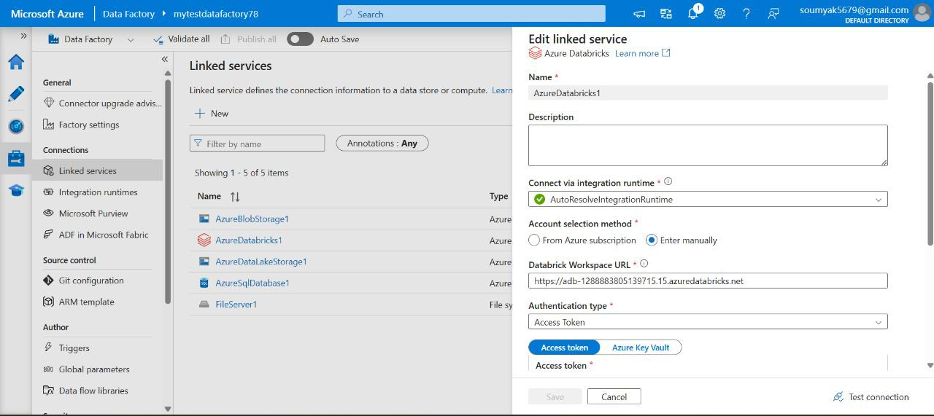

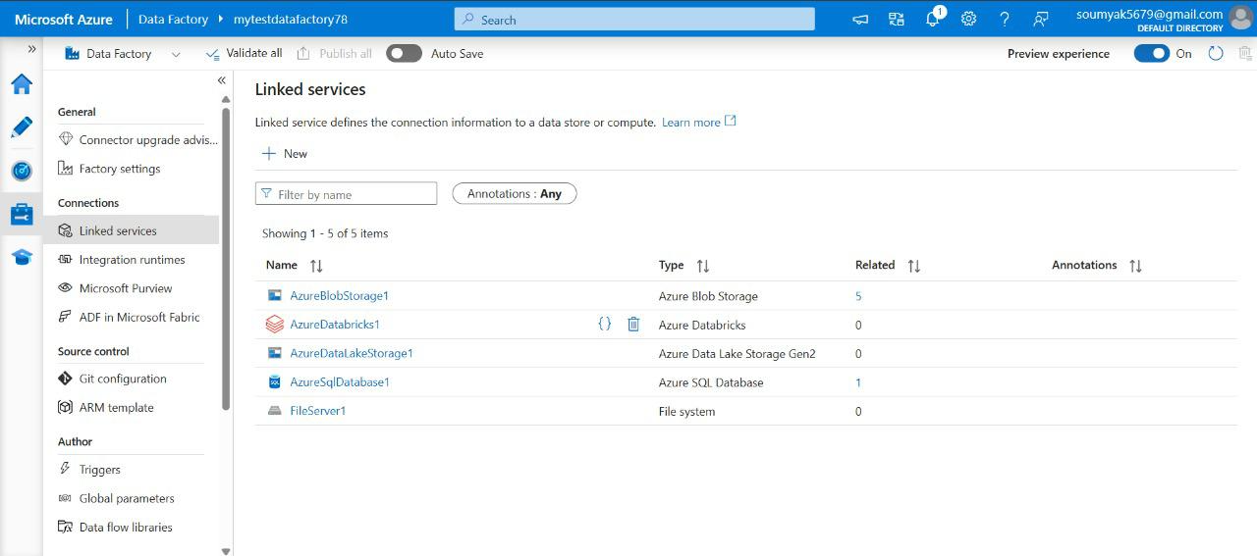

*Figure 3.13: Integration runtime setup and Linked Service configuration*

Automating Data Pipelines with CI/CD

Automating data pipelines has become an essential part of modern data management, especially as organizations strive for greater efficiency and reliability. One of the most effective ways to streamline this process is by implementing Continuous Integration and Continuous Deployment, or CI/CD, within Azure Data Factory.

CI/CD is a set of practices that enable software and data teams to deliver updates to their systems more frequently and reliably. In the case of Azure Data Factory, CI/CD allows data engineers to develop, test, and deploy data pipelines quickly, all while maintaining version control and minimizing manual errors.

Manually managing data pipelines can be tedious and error-prone, especially as the complexity of your workflows grows. Automation not only reduces the time spent on repetitive tasks but also ensures consistency across different environments—whether you’re working in development, testing, or production. By adopting CI/CD, you can quickly roll out changes, fix bugs, and introduce new features with minimal disruption.

The typical CI/CD process in Azure Data Factory involves a few key components:

* **Version Control Integration**: The first step is to connect your Data Factory instance to a source control system like Azure DevOps Git or GitHub. This way, any changes you make are tracked and can be reviewed or rolled back as needed.
* **Development and Testing**: Data engineers create and test their pipelines in a development environment. Thanks to version control, multiple team members can collaborate without stepping on each other's toes.
* **Continuous Integration**: Once changes are committed, automated build and validation processes kick in. This typically involves running unit tests and verifying that the pipelines are configured correctly.
* **Continuous Deployment**: If everything checks out in integration, the updates are automatically pushed to the production environment. This deployment can be triggered manually or scheduled, depending on your organization's needs.

Automating your data pipelines with CI/CD in Azure Data Factory brings several significant advantages:

* **Reliability**: Automated testing catches issues early, reducing the risk of faulty data flows reaching production.
* **Speed**: Changes move from development to production much faster, thanks to streamlined workflows and fewer manual steps.
* **Collaboration**: With source control, multiple team members can work on different pipelines or features simultaneously, all without causing conflicts.
* **Traceability**: Every change is logged, making it easy to trace when, why, and how a particular update was made.

To implement CI/CD in Azure Data Factory, start by linking your Data Factory workspace to a Git repository. From there, you can use Azure DevOps pipelines or GitHub Actions to automate building, testing, and deploying your data pipelines. Take advantage of built-in templates and community resources to get up and running quickly. Incorporating CI/CD practices into your Azure Data Factory workflow is a smart move if you're aiming for efficiency and reliability. Not only does it make your data operations smoother, but it also frees up your team to focus on what really matters: delivering insights and value from your data. Here are the steps to setup Automated Data pipelines.

* Step 1: Connect your Azure Data Factory to a Git repository (Azure DevOps or GitHub).
* Step 2: Use feature branches and pull requests for collaborative development.
* Step 3: Set up Azure Pipelines for automated deployment to test and production environments.
* Step 4: Use ARM templates or Data Factory REST API for deploying resources programmatically.

Example CI/CD Workflow:

- Develop pipeline changes in feature branch

- Commit and push to remote repository

- Automated build validates ARM templates

- Deploy to test environment on pull request merge

- After testing, promote to production via release pipeline

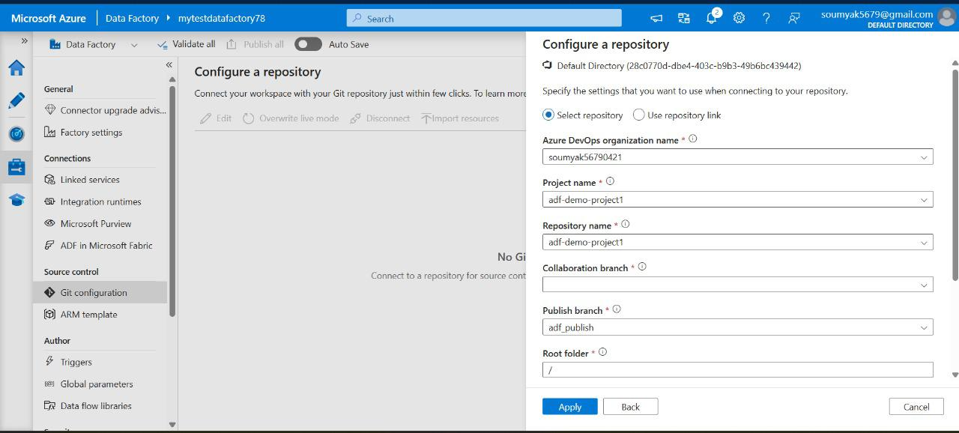

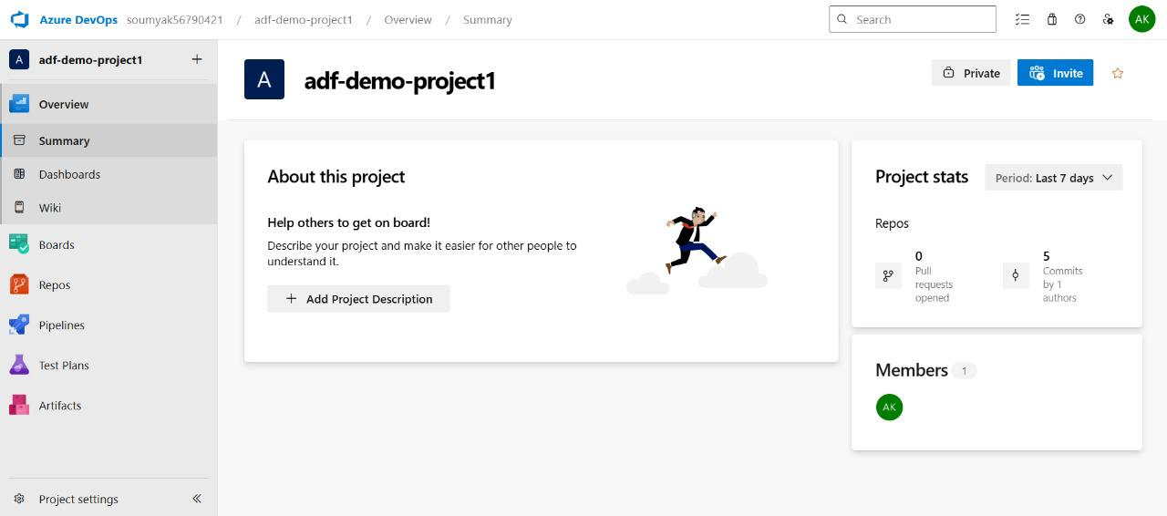

*Figure 3.14: CI/CD pipeline setup in Azure DevOps*

# Benefits of using ADF for ETL/ELT Services

ADF brings a host of advantages to ETL (Extract, Transform, Load) and ELT (Extract, Load, Transform) processes:

* **No-Code/Low-Code Experience**: The visual interface and drag-and-drop pipeline design reduce barriers for data engineers and analysts to build and manage data flows efficiently.
* **Flexible and Scalable**: Easily scale up or out to process massive datasets, thanks to cloud-native architecture and Spark-based Data Flows.
* **Rich Transformation Capabilities**: Tackle complex data transformations with built-in expressions, mapping, joins, aggregations, and conditional logic.
* **Automated Scheduling and Triggering**: Pipelines can be set to run on schedules, in response to events, or via APIs, supporting both batch and real-time scenarios.
* **Integrated Data Movement**: Move data between cloud, on-premises, and SaaS sources without heavy lifting or complex custom code.
* **Cost Efficiency**: Only pay for what you use, with pricing based on pipeline activity and data volume, which often results in lower total cost of ownership.
* **Enterprise Support**: Backed by the Azure support network, SLAs, and an active user community, troubleshooting and scaling are rarely a challenge.

In summary, Azure Data Factory shines as a comprehensive, flexible, and enterprise-ready solution for data integration and transformation. Its feature-rich environment, deep Azure integration, and extensive support for hybrid and iPaaS scenarios make it a top choice when compared to AWS Glue and Google Data Fusion—especially for businesses looking for secure, scalable, and cost-effective ETL/ELT services.

ADF has become a mainstay in cloud-based data integration, thanks to its rich feature set, flexibility, and tight integration with the Microsoft ecosystem. When considering enterprise-scale data orchestration and transformation, ADF often stands out from competitors like AWS Glue and Google Cloud Data Fusion depending on the ways of implementation including architectural resiliency and standardization of best practices.

# Best Practices for Implementing ADF

* **Design Modular Pipelines**: Break down complex workflows into reusable, manageable components. Modular pipelines not only make maintenance easier but also encourage reusability and reduce operational overhead.
* **Parameterize Everything**: By parameterizing datasets, linked services, and pipelines, you can make your solutions dynamic and adaptable to various environments (dev, test, prod) with minimal changes.
* **Use Integration Runtimes Wisely**: ADF offers different types of integration runtimes (Azure, Self-Hosted, and SSIS). Choose the appropriate runtime based on your data movement and transformation needs, especially for on-premises or VNet-restricted sources.
* **Implement Robust Monitoring and Alerting**: Leverage built-in monitoring, logging, and alerts. Use the ADF monitoring interface, Azure Monitor, and Log Analytics to get insights into pipeline runs, failures, and performance bottlenecks.
* **Secure Your Data and Credentials**: Use managed identities and Azure Key Vault to store and access secrets, connection strings, and sensitive credentials securely. Always implement least privilege access policies.
* **Optimize Data Flows**: When using Data Flows for transformation, pay attention to partitioning, data skew, and caching options to improve performance and cost-effectiveness.
* **Version Control with Git Integration**: Connect your ADF instance to Azure DevOps or GitHub for source control, collaboration, and CI/CD automation. This helps ensure changes are tracked, reviewed, and deployed systematically.
* **Cost Management**: Monitor activity runs and integration runtime usage. Clean up unused resources promptly and leverage cost management tools to stay within budget.

## Comparing with AWS Glue and Google Data Fusion

Azure Data Factory, AWS Glue, and Google Cloud Data Fusion each offer solid cloud data integration capabilities, but ADF stands out in several areas:

* **Rich Integration**: ADF natively connects with a broad range of Azure services, on-premises sources, and third-party platforms, making it ideal for organizations heavily invested in Microsoft technologies.
* **Flexible Development Options**: ADF supports a code-free visual UI, rich parameterization, custom activities (via Azure Functions, Databricks, or HDInsight), and full code-based support using SDKs or REST APIs.
* **Cost Control and Transparency**: With pay-per-use pricing and granular activity-based billing, ADF often makes costs more predictable.
* **Security and Compliance**: Azure’s global compliance coverage, combined with ADF’s security model (managed identities, VNet integration, encryption), is particularly attractive for enterprises with strict governance requirements.
* **Data Flow Capabilities**: ADF’s Data Flows enable transformation at scale, using a graphical design environment and Spark-based execution that's easy to tune.

## Below table summarizes the feature comparison of ADF with AWS Glue and Google Data Fusion.

|  |  |  |  |
| --- | --- | --- | --- |
| Feature | Azure Data Factory | AWS Glue | Google Data Fusion |
| Integration with Cloud Ecosystem | Deep Azure integration | Tightly integrated with AWS | Seamless GCP integration |
| Development Interface | Visual UI & code-based | Primarily code-based (PySpark, Scala, Python) | Visual UI (based on CDAP) |
| On-Premises Connectivity | Self-hosted Integration Runtime | Via VPC, needs Glue Connectors | Hybrid connectivity with secure agents |
| ETL/ELT Capabilities | Strong, supports both ETL and ELT | ETL-focused, supports some ELT | ETL-focused |
| Data Transformation | Data Flows (visual, Spark-based) | PySpark scripts | Wrangler, pipelines (visual) |
| Monitoring & Management | Comprehensive, real-time, Azure Monitor | Basic job monitoring | Basic monitoring, Stackdriver |
| Security Features | Managed identities, Key Vault, VNet | AWS IAM, KMS, VPC | IAM, Secret Manager, VPC |
| Pricing Model | Pay-as-you-go, activity-based | Pay-as-you-go, per-DPU/hour | Pay-as-you-go, per instance |
| Global Compliance | Extensive (GDPR, HIPAA, etc.) | Strong (FedRAMP, HIPAA, etc.) | Good (GDPR, HIPAA, etc.) |
| CI/CD Integration | Azure DevOps, GitHub | Manual, AWS CodePipeline | Cloud Build, Bitbucket |

# *Table: Feature Comparison Table with ADF, AWS Glue and Google Data Fusion*

Conclusion

Azure Data Factory offers a robust, scalable, and flexible platform for ingesting and transforming data in the cloud. By following the detailed recipes and leveraging the examples provided in this chapter, data engineers can design efficient, reliable, and automated data pipelines that power modern analytics and AI workloads. As you experiment with these recipes and tailor them to your own projects, you will gain a deeper mastery of Azure Data Factory and the broader Azure data ecosystem.

Ingesting data using Azure Data Factory encompasses a comprehensive set of skills and strategies—from pipeline construction and transformation logic to robust error handling and performance monitoring. For academic students and Azure architects, mastering these concepts unlocks the full potential of Azure’s data integration ecosystem. By leveraging best practices, real-world examples, and continuous improvement, practitioners can build reliable, scalable, and efficient data solutions that empower data-driven innovation across industries.